**Glen Issac**

**200499313**

**Lab 2 Document (Unix Screenshots)**

**Step 1**



Step 2

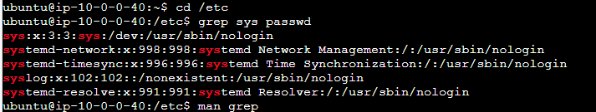

Step 3



Step 4

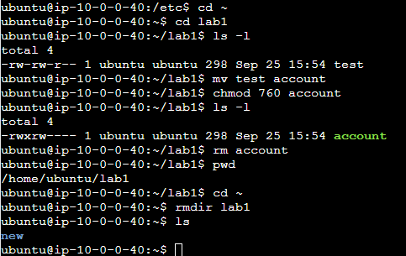

//max.c

#include <stdio.h>

int main(){

int arr[] = {18, 3, 42, 83, 28, 16, 9, 190};

int n = sizeof(arr) / sizeof(arr[0]);

// Bubble sort in descending order

for (int i = 0; i < n - 1; i++) {

for (int j = 0; j < n - i - 1; j++) {

if (arr[j] < arr[j + 1]) {

// Swap

int temp = arr[j];

arr[j] = arr[j + 1];

arr[j + 1] = temp;

}

}

}

printf("{");

for (int i = 0; i < n; i++) {

printf("%d ", arr[i]);

}

printf("}");

}

//bill.c

#include <stdio.h>

#include <math.h>

int main() {

double amt;

int dollars, cents;

printf("Enter an amount: ");

scanf("%lf", &amt);

// Break into dollars and cents

dollars = (int)amt;

cents = (int)round((amt - dollars) * 100);

printf("You owe:\n");

// Place values (powers of 10)

int placeValues[] = {1, 10, 100, 1000, 10000, 100000};

char *labels[] = {"$1 bill", "$10 bill", "$100 bill", "$1000 bill", "$10000 bill", "$100000 bill"}; //i got tired after this

int arr[20], size = 0;

int temp = dollars;

while (temp != 0) {

arr[size++] = temp % 10;

temp /= 10;

}

// print with proper labels

for (int i = size - 1; i >= 0; i--) {

if (arr[i] > 0) {

printf("%d %s%s\n", arr[i], labels[i], (arr[i] > 1 ? "s" : ""));

}

}

if (cents > 0) {

printf("%d cent%s\n", cents, (cents > 1 ? "s" : ""));

}

return 0;

}

//coin.c

#include <stdio.h>

#include <stdlib.h>

#include <time.h>

int main(){

int ct_head = 0;

int ct_tail = 0;

// Generating random seed

srand(time(NULL));

for (int i = 0; i<100; i++) {

int gen = rand() %2;

if (gen == 0) {

ct_head++;

}

else {

ct_tail++;

}

}

printf("Number of Heads = %d\n", ct_head);

printf("Number of Tails = %d\n", ct_tail);

return 0;

}